Common Security Module and
User Provisioning Tool 5.0
User’s Guide Update
11/29/2012

[Type the abstract of the document here. The abstract is typically a short summary of the contents of the document. Type the abstract of the document here. The abstract is typically a short summary of the contents of the document.]

Contents
Document Change History 2
1. Purpose 3
2. NIH Password Policy 3
Change Password 3
3. User account activation. 5
Deactivate User 5
Activate User 6
4. Configurable Password Management 7
5. Account lockout threshold setting 8
6. Migration 8
Appendix A Description of properties 8

Document Change History
Version | Date | Changed by | Description
1.0 | 11/29/2012 | Mahidhar Narra | NIH password policy

Purpose
This document provides modification of User’s Guide for Common Security Module (CSM) and User Provisioning Tool (UPT) 5.0 version. It lists step-to-step instructions for user to perform CSM/UPT functionalities implemented by this version. This version addresses functional improvements as well as usability improvements.
Functional Improvements include:
- User account activation.
- NIH Password Policy enforcement.
- Configurable password management.
Usability Improvements include:
- Account lockout threshold setting.
Instead of providing design details for all features of 5.0 versions, this draft document focuses on Configurable User Provisioning Operations, other feature maybe added in later or described with separated document.

2. NIH Password Policy

Change Password
The UPT application will redirect to the change password screen when the user password is expired or the user is logs in for the first time after being created. The page will collect the old password, new password and the application context for which the user belongs. The user credentials will be posted to the CSM API changePassword() method to update the new password

The figure shows the change password UI fields for the UPT web modules
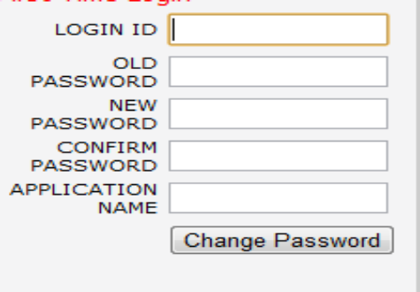

The new password should comply with the NIH password policy and should contain at least 8 characters a special character, a number and an uppercase letter.
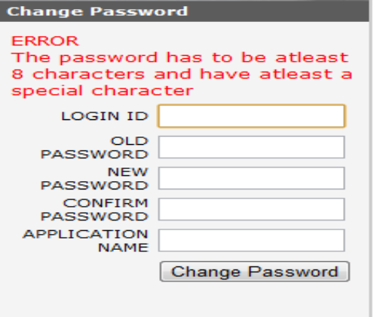
After successful login the page will be redirected to the login page.
The application user can change his user information by login to the application using UPT
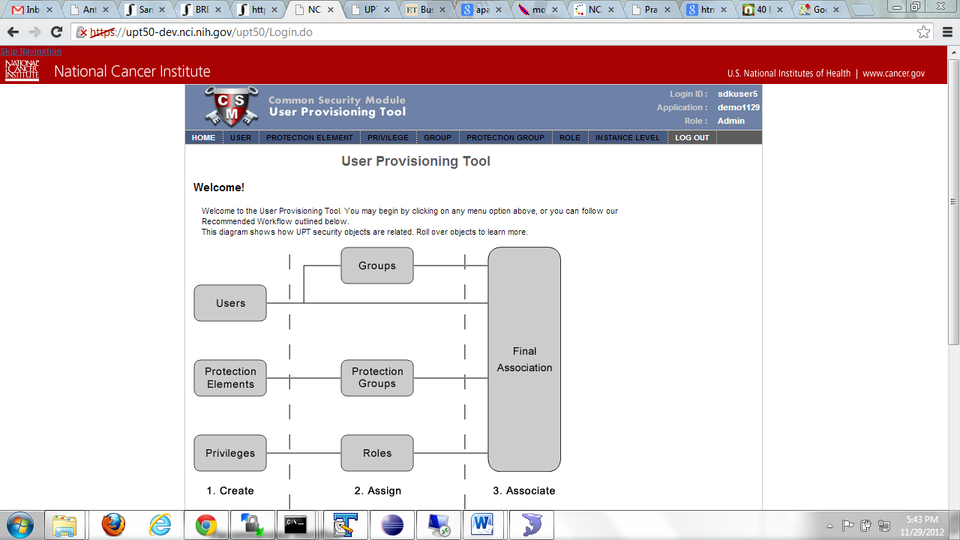
All the other links will disabled and user can click on the username on top right hand side of the page
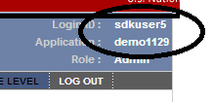
The User can change his user information and the password and click on update
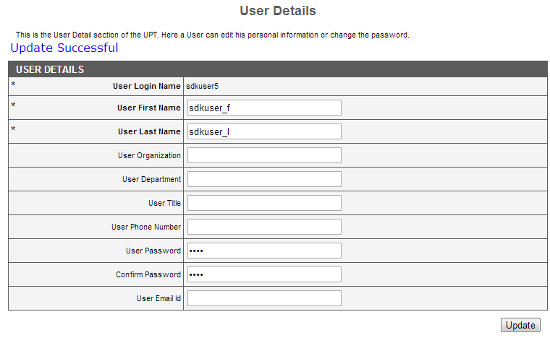

3. User account activation.

Deactivate User
The UPT application can be used to activate a deactivated user and likewise deactivate a user. The activate/deactivate feature will be provided only to admin user. When deactivated, the user can not be
Authenticate and will be prompted a message with the same.

The figure shows an active flag which can be set to “No” to deactivate a user.
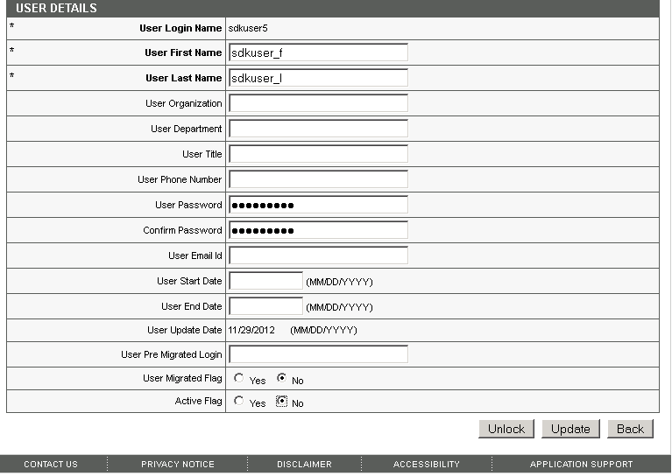

The figure shows a message when a deactivate users logs in to the system

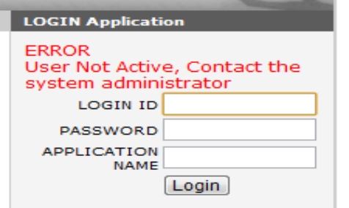

Activate User
The user can be activated by setting the active flag to true and clicking on update

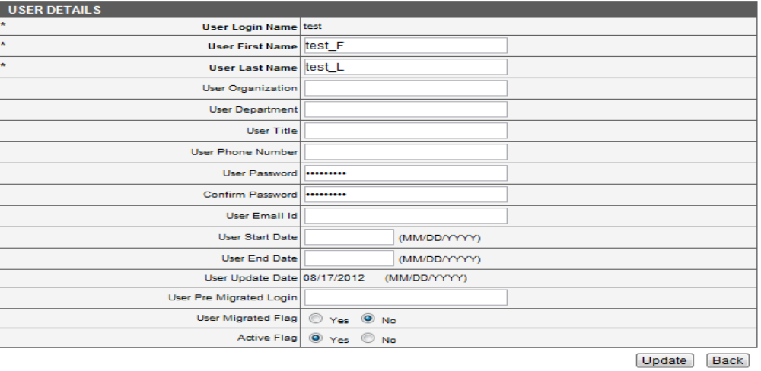

4. Configurable Password Management

The UPT application can be used to configure the system properties for UPT application. The system properties can be viewed and edited by the superadmin
The figure shows the system properties used by the CSM which can be viewed/updated from UPT
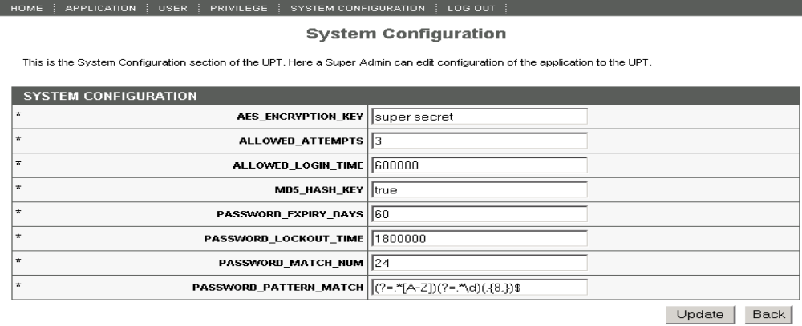

5. Account lockout threshold setting
The UPT application can be used to configure the Threshold values from the UPT application. The System Configuration will be enabled when the user logs in as the superadmin.

The below properties can be updated by the superadmin

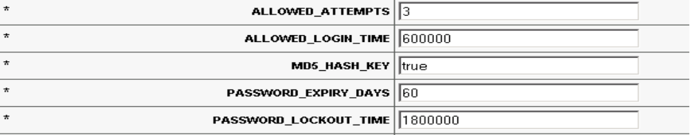

6. Migration
Currently, the passwords are encrypted using DES standard, since DES is considered vulnerable, the passwords and the Personally Identifiable Information (PII) will be encrypted using AES standard. The existing users and applications will need to encrypt the information using the AES standard. A migration utility will be provided to migrate the existing users. This utility will decrypt the existing passwords and encrypt with the new standard.
The users will be migrated using a java based utility. The utility can be run from the install script after upgrading to the 5.0 release. The users can run
ant migration:run
The script reads the database details from the upgrade.properties used during the upgrade and pass them to the driver file that migrates the users. The Driver files decrypts the users and the applications and encrypts them with the new AES standard

Appendix A Description of properties

PROPERY_NAME | PROPERY_DESCRIPTION | PROPERY_VALUE
AES_ENCRYPTION_KEY | Key used to encrypt the user information
ALLOWED_ATTEMPTS | This is the allowed password attempts for the user | 3
ALLOWED_LOGIN_TIME | The time to enter the valid passwords | 600000(milli sec)
MD5_HASH_KEY | Key to allow 128 or 256 bit encryption | true
PASSWORD_EXPIRY_DAYS | Number of days the password is valied | 60
PASSWORD_LOCKOUT_TIME | Time the user will be locked out | 1800000(milli sec)
PASSWORD_MATCH_NUMBER | Previous passwords that can now be used | 24
PASSWORD_PATTERN_MATCH | The regular used expression to match the password | (?=.*[A-Z])(?=.*\d)(.{8,})$ (password must be greater than 8 characters, at least a special character and an uppercase letter

